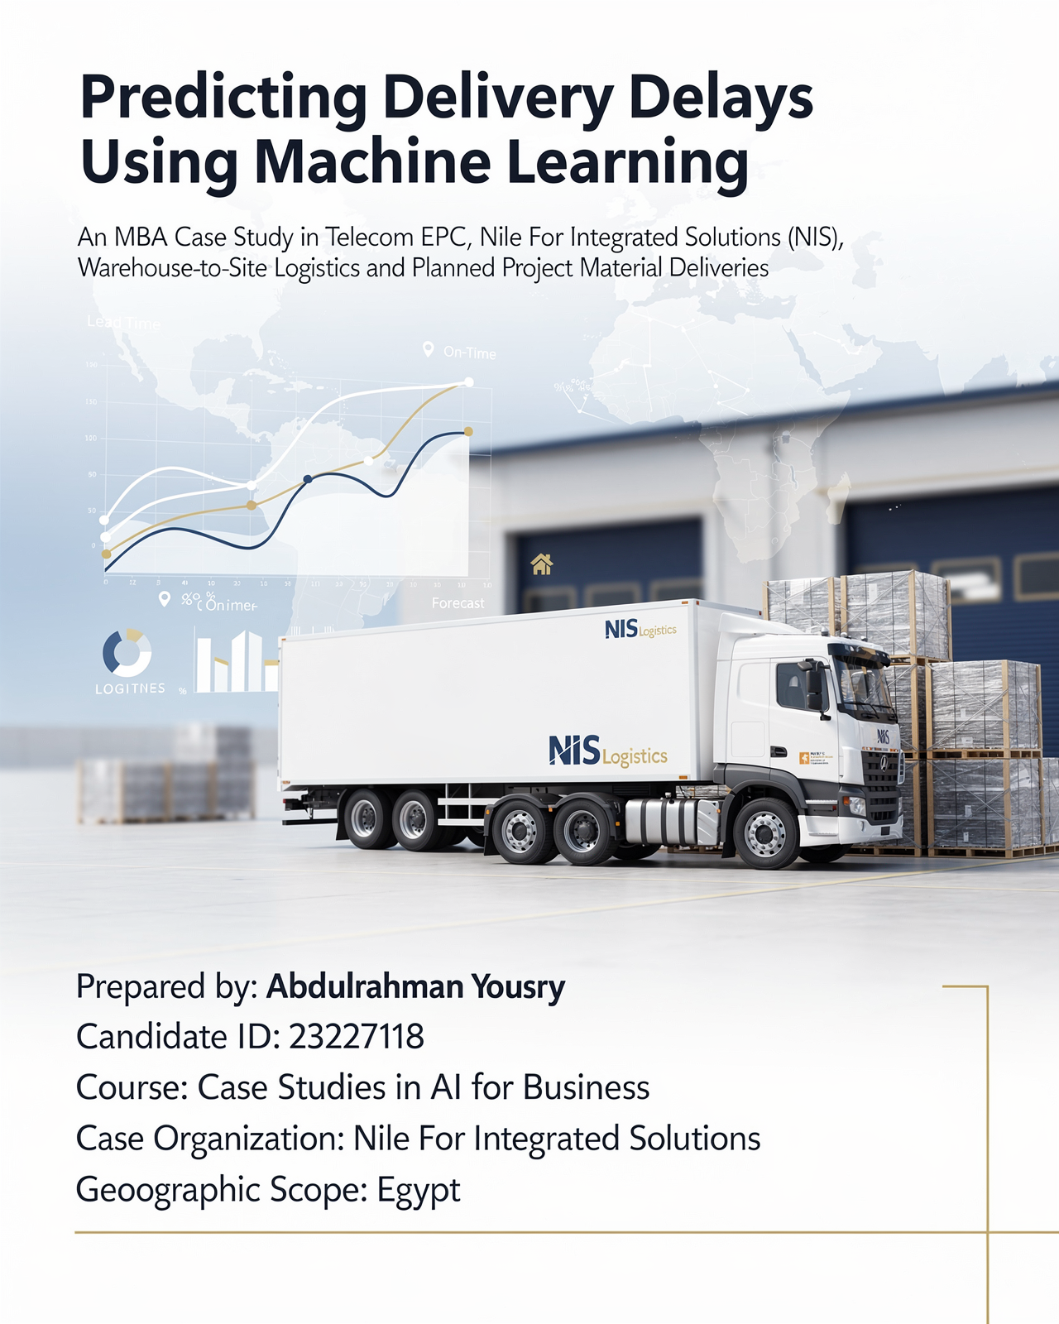

Predicting Delivery Delays Using Machine Learning
An MBA Case Study in Telecom EPC, Nile For Integrated Solutions (NIS), Warehouse-to-Site Logistics and Planned Project Material Deliveries
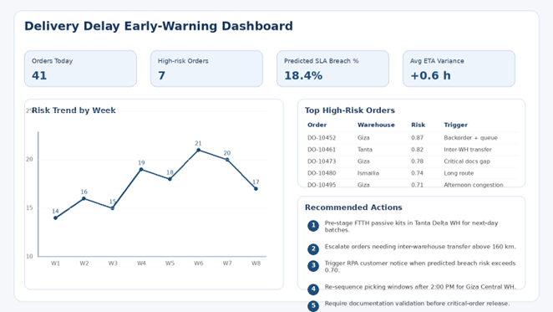

Abstract
This paper discusses how Nile For Integrated Solutions (NIS), a front company in the field of telecommunications engineering contracting, can use machine learning to predict delivery delays in warehouse-to-site logistics and in the supply of materials for planned projects.
The problem is of strategic importance because delays in field communications operations not only lead to slow implementation, but also cause breaches of Service Level Agreements (SLAs), downtime for technical teams, costly emergency transfers, impaired visibility of the ERP system, and direct exposure to fines and financial leakage.
The analysis was structured as a case study using a simulated dataset designed to mimic a real-world telecommunications operating environment: 14,600 delivery history records, three warehouses, fifty field teams, and an average of forty orders per day. The data was modeled on a Telecom custom ERP system integrated with Odoo inventory and warehouse reporting, reflecting an environment where ERP data is structured but vehicle tracking and IoT data are not available.
The study combines descriptive, diagnostic, predictive, and prescriptive analyses. Three supervised learning models were compared: Logistic Regression, Random Forest, and XGBoost. The XGBoost model achieved the best overall performance with an ROC-AUC of 0.936 and an accuracy of 0.889, making it the preferred model for operational deployment.
The results show that the strongest predictors of delays are long distances, transfers between warehouses, backorder risks, queue congestion, narrow SLA targets, incomplete documentation, and afternoon dispatch pressure. In addition to modeling, the paper assesses the impact of digital transformation, ERP integration logic, robotic process automation (RPA) opportunities, Hybrid Agile SDLC governance, and risk controls aligned with GDPR and ISO/IEC 27001 principles. The study concludes that AI only creates measurable value when predictions are integrated into operational workflows, ERP transactions, escalation rules, and decision-making rights, rather than being treated as a separate analytical experience. (Akbari & Do, 2021; Lam et al., 2024; Moumane et al., 2024).
Keywords: Telecom EPC, delivery delay prediction, machine learning, ERP, Odoo, digital transformation, field logistics, RPA, XGBoost

Tabel Of Content.
- 1. Industry and business context
- 2. Problem statement
- 3. Data analytics component
- 4. AI solution overview
- 5. Analytical techniques applied and findings
- 6. Digital transformation analysis
- 7. ERP integration and process design
- 8. SDLC methodology and RPA role
- 9. Business impact and value creation
- 10. Risks, ethical issues, limitations and ISO/IEC 27001 alignment
- 11. Recommendations and future scope
- 12. Conclusion
- References

1. Industry and Business Context
Egypt’s telecom market is one of the largest in Africa and the Arab world, and it operates in a highly competitive environment shaped by broadband expansion, mobile quality expectations, and continuous infrastructure investments (National Telecom Regulatory Authority [NTRA], n.d.-a). From an EPC contractor’s perspective, this means that field execution is no longer judged only by engineering quality; it is also judged by speed, predictability, and the ability to meet tightly managed service windows.
This pressure intensifies as networks continue to expand. The NTRA's Q4 2024 Mobile Network Quality Report indicated the approval of 748 new stations during that quarter, reflecting continued investment and the demand for rapid and orderly implementation (National Telecom Regulatory Authority, 2025). In such a context, material delays become a direct factor impacting productivity, quality, and on-time delivery.
The organization under study is Nile For Integrated Solutions (NIS), a disguised case study of a Telecom EPC company operating in Egypt and serving fixed network, FTTH, transport, and mobile network upgrade projects. The company relies on three warehouses, fifty field teams, and an average of forty delivery orders per day. Operations are managed through a Telecom custom ERP with an operational layer for inventory and warehousing in Odoo, allowing for relatively good operational reporting but lacking predictive capabilities or real-time tracking.
The unique aspect of this type of logistics is that the receiving point is not a fixed customer address as in retail, but rather a variable project location, which may be in a remote area and depends on the readiness of teams, documentation, and the availability of specific materials. Therefore, the decision to ship is not merely a transportation decision, but an operational one that links warehouses to projects, technical teams, and contractual obligations.

1.1 Market conditions and competitive environment
The competitive environment shapes logistics behavior in two parallel directions. On the one hand, major operators and integrators expect predictable execution and a clear view of service quality. On the other hand, EPC companies operate within tight time and financial margins, where even a small delay leads to rescheduling of teams, delayed deliveries, and increased emergency transportation costs. Therefore, the ability to predict delays early becomes an operational and strategic advantage, not merely an additional analytical tool. (Baryannis et al., 2019; Davenport & Brooks, 2004).

Warehouse | Orders | Breach rate (%) | Avg. lead time (hrs)
Giza Central WH | 6849 | 21.3 | 3.62
Ismailia Canal WH | 3286 | 17.8 | 3.73
Tanta Delta WH | 4465 | 21.2 | 3.73

Table 1. Warehouse-level performance profile used in the case dataset.

2. Problem Statement
The central problem in this case is the company's inability to predict which orders are at risk of exceeding the SLA before the breach actually occurs. Traditional systems based on periodic reports show what has already happened, but they do not provide an estimate of the probability of failure for open orders, nor do they allow for proactive resource allocation.

Traditional decision-making methods proved inadequate for three reasons. First, static ERP reports summarize past performance and fail to assess future risks. Second, operational follow-up relies on individual calls, messages, and assessments, leading to inconsistent responses from one supervisor to another. Third, the causes of delays—such as distance, stock shortages, warehouse congestion, missing documentation, and inter-warehouse transfers—intertwine in a way that cannot be efficiently managed through simple rules or individual human judgment (Baryannis et al., 2019; Davenport & Brooks, 2004).
This results in operational, strategic, and financial gaps. Operationally, technical teams are waiting for materials or having their work rescheduled. Strategically, management's ability to identify real bottlenecks and confidently plan expansion is weakened. Financially, this leads to penalties, additional coordination costs, and leakage of productivity and revenue associated with the execution phases.
The case therefore asks a practical question: can machine learning convert historical ERP data into a forward-looking control mechanism that improves delivery reliability without requiring a full IoT stack? This business logic is aligned with literature arguing that AI creates value when operational data is converted into proactive coordination and control mechanisms (Akbari & Do, 2021; Lam et al., 2024).

2.1 Operational and financial symptoms
- Frequent SLA breaches in planned deliveries from warehouse to site.
- Increased logistics costs due to emergency transport and unplanned relocation decisions.
- Reduced technician productivity when teams are moved before materials arrive.
- Poor visibility within the ERP system because reports describe past events and fail to capture current risks.
- Financial leakage and potential penalties when execution phases are delayed without prior warning.

3. Data Analytics Component
The data analytics component is essential in this case because the proposed AI capability depends entirely on transforming fragmented operational records into a reliable analytical asset for decision-making. In other words, the quality of the model cannot exceed the quality of the data and operational logic used to build it.
The study uses a simulated dataset modeled on realistic telecom operations mixed with a live company export. This choice protects confidentiality while preserving the operational logic of the case. The final dataset contains 14,600 delivery records for the 2025 operating year, consistent with the company’s average of forty daily orders.
The data is primarily structured and historical. It is generated to resemble exports from a telecom custom ERP, Odoo-based warehouse inventory reports, project scheduling records, and exception logs. Odoo documentation is relevant because its inventory module supports lead times, replenishment logic, inter-warehouse transfers, and route rules, all of which directly affect delivery planning (Odoo S.A., n.d.-a, n.d.-b, n.d.-c, n.d.-d). In deployment, the same architecture would also consume near-real-time transaction events from order confirmation, warehouse release, and site receipt updates.
The lack of vehicle tracking and IoT data is a significant limitation of this project; the model cannot rely on live GPS coordinates or dynamic traffic data. Therefore, the modeling is based on signals closest to available operational realities, such as queue pressure, warehouse transfers, inventory status, SLA target narrowing, dispatch timing, and document completeness.
From an analytics architecture perspective, the case uses the full decision ladder. Descriptive analytics measures current performance patterns; diagnostic analytics identifies likely root causes; predictive analytics estimates the probability of a delivery breach; and prescriptive analytics recommends actions such as re-sequencing, stock reallocation, escalation, or proactive communication. This layered approach matters because prediction alone is not a business solution unless it changes decisions. The logic is consistent with business-oriented data mining, where analytics should progress from understanding to action rather than stopping at pattern description (Shearer, 2000; Schröer et al., 2021).

3.1 Data types and sources used
Source | Data type | System | Business value
Historical order transactions | Structured / historical | Telecom custom ERP order header and lines | Training data for delay prediction; promised vs. actual delivery performance
Warehouse movements | Structured / near-real-time | Odoo inventory and warehouse reports | Picking queue, release timestamp, stock availability, route and transfer status
Project schedule records | Structured | Project operations module / work-order planning | Site windows, crew dependencies, planned milestone sequencing
Master data | Structured | ERP reference tables | Warehouse, region, material class, priority, supplier and SLA definitions
Exception and escalation logs | Semi-structured | ERP notes / coordination logs | Used to enrich root-cause interpretation and exception handling
Customer/site notifications | Semi-structured | Email/SMS workflow logs | Used mainly for response timing and service communication audit

Table 2. Data sources used in the simulated case architecture.

3.2 Analytics types used
Analytics type | Decision question | Case application
Descriptive analytics | What happened? | Monthly SLA breach rate, average lead time, breach rate by warehouse/priority/region
Diagnostic analytics | Why did it happen? | Root-cause shares: queue congestion, route complexity, stock shortage, inter-warehouse transfer, documentation gaps
Predictive analytics | What is likely to happen? | Probability that an open delivery order will breach SLA
Prescriptive analytics | What should we do next? | Re-sequence picking, pre-stage material, escalate stock transfer, notify site, log exception automatically

Table 3. Analytics ladder applied in the case study.

3.3 Feature engineering logic
The set of properties combines transactional, operational, and managerial variables. Some of these variables come directly from the ERP, while others are derived to reflect operational logic that isn't explicitly stated. For example, distance alone doesn't reveal the true risk, so it was converted into categories that reflect route complexity. Similarly, an SLA tightness index was created to measure the difference between the promised time and the expected time based on the operational baseline. (Steinberg et al., 2023; Müller et al., 2025).
Feature | Type | Business meaning
Distance bucket | Engineered categorical | Captures route complexity and long-haul risk
Inter-warehouse transfer | Binary | Indicates dependency on stock movement between warehouses
Stock status | Categorical | Available, partial shortage, or backorder risk
Documentation complete | Binary | Reflects readiness of paperwork before dispatch
Pick queue | Numeric | Current warehouse workload at order release
Team utilization | Numeric | Pressure on receiving field teams and execution capacity
Promised lead hours | Numeric | Operational SLA target for the order
SLA tightness | Engineered numeric | Difference between promised time and baseline transit/loading expectation
Priority | Categorical | Planned, urgent, or critical
Shift | Categorical | Morning versus afternoon dispatch behavior
Manual reschedules | Numeric | Number of rescheduling interventions before release
End-of-month flag | Engineered binary | Captures milestone pressure near monthly close

Table 4. Example feature dictionary for the predictive model.
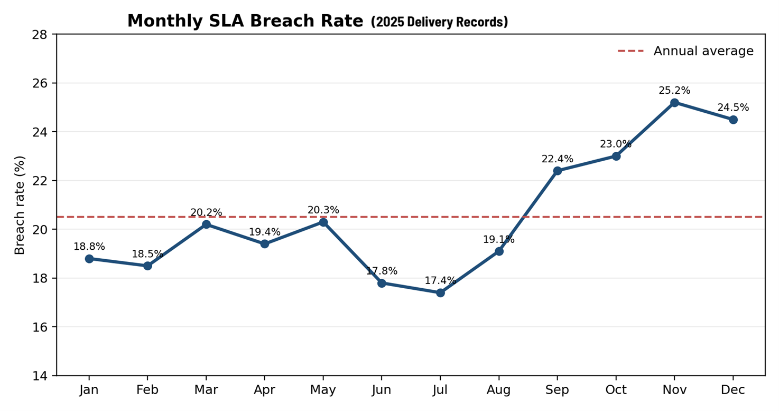
Figure 1. Monthly SLA breach rate across the simulated 2025 delivery dataset.

4. AI Solution Overview
The technique chosen in this case is Supervised Machine Learning within a Binary Classification task. The target variable is SLA violation, defined as a situation where the actual delivery time exceeds the promised time. This choice is appropriate to the nature of the problem because the organization has tagged historical records that allow it to distinguish between on-time and late orders.
Three algorithms were tested: Logistic Regression as an interpretable baseline, Random Forest as a non-linear ensemble benchmark, and XGBoost as a more advanced gradient-boosted model. This comparison was intentionally chosen to balance interpretability, operational performance, and executive credibility. The model portfolio also reflects common managerial practice in applied logistics analytics, where interpretable baselines are compared with more powerful ensemble methods (Akbari & Do, 2021; Müller et al., 2025).
The case study also illustrates the role of unsupervised and semi-supervised learning, although they are not the primary production model. Unsupervised learning is useful in uncovering patterns in workflows or risk groups that were not visible to management. Semi-supervised learning becomes important when some causes of delays are not fully identified in existing records, a common occurrence in real-world operating environments. In many EPC firms, orders are labelled with outcome dates but not consistently tagged with a root cause. Semi-supervised methods can leverage the large body of unlabelled operational records to improve classification or delay-cause tagging when manual annotation is incomplete (van Engelen & Hoos, 2020).
The literature supports this trend; recent reviews indicate that predicting delivery delays has become an increasingly important focus in supply chain management, but it still faces a gap between academic models and usable operational applications within organizations (Müller et al., 2025; Gabellini et al., 2024). Other studies show that supplier or delivery delay prediction becomes more valuable when feature engineering captures operational detail rather than using only broad aggregates (Steinberg et al., 2023; Gabellini et al., 2024). In practical terms, this means that NIS should not ask, ‘Which algorithm is fashionable?’ but rather, ‘Which algorithm turns our ERP data into reliable early warning with manageable false alarms?’
Therefore, characteristic engineering was central to the study. In addition to the base variables, the model used derived characteristics such as distance class, queue pressure, capacity-demand gap, SLA tightness, document status, and dispatch time. The goal was not only to increase statistical accuracy but also to produce a model that explains operational reality in a language understandable to management. For example, SLA tightness translates a managerial intuition into data: some deliveries look short on paper, but the promised lead time leaves very little recovery margin once distance, congestion, and warehouse load are considered. Prior studies similarly find that delay prediction improves when engineered variables represent real operational constraints rather than only generic demand or time indicators (Steinberg et al., 2023; Gabellini et al., 2024).

4.1 Supervised, unsupervised and semi-supervised learning in the case
ML mode | Data requirement | Role in this case
Supervised learning | Labeled data (on time vs. delayed) | Primary production model for SLA breach prediction
Unsupervised learning | Unlabeled data pattern discovery | Route clustering and risk archetype discovery for management insight
Semi-supervised learning | Small labeled set + large unlabeled set | Future improvement for delay-cause tagging when exception labels are incomplete

Table 5. Why different machine-learning modes matter even though supervised learning is the production choice.

4.2 Business functions impacted
- Supply chain and warehouse management: Prioritization, inventory allocation, and transfer decisions.
- Project operations: site sequencing, crew coordination, and milestone assurance.
- Finance: Clearer visibility into penalties and avoidable costs.
- Communication with customers and stakeholders: Faster ETA updates and greater service transparency.
- Management control: Shared cross-functional visibility into risk levels and bottlenecks.
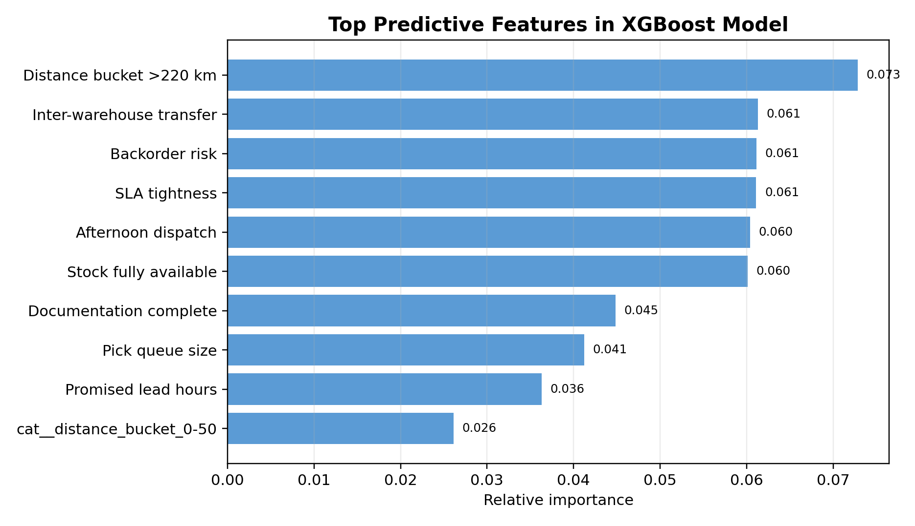
Figure 2. Top predictive features in the selected XGBoost model.

5. Analytical Techniques Applied and Findings
The descriptive layer reveals high operational activity but structural bottlenecks. Over the simulated year, the average actual delivery time was 3.68 hours compared to a lower promised average, and the overall SLA breach rate was 20.5%. This means that approximately one in five orders was at risk of failure within the current system.; the more meaningful indicator is the tail of orders that become late under pressure. Monthly analysis shows a clear deterioration from September to December, consistent with year-end delivery concentration, cumulative queue pressure, and tighter milestone commitments.
Diagnostic analytics shows that delays are not dominated by one single cause. Among delayed orders, warehouse congestion represented 32.6% of the primary drivers, followed by distance and route complexity at 20.9%, inventory shortage at 20.1%, inter-warehouse transfer dependency at 13.8%, and documentation issues at 12.6%. The managerial implication is important: the organization does not need only better transport control; it needs earlier cross-functional coordination among warehouse planning, stock allocation, document release, and project scheduling.
The predictive analytics stage compared the three models on the same training and test design. XGBoost delivered the strongest overall performance with ROC-AUC 0.936, accuracy 0.889, precision 0.757, recall 0.678, and F1-score 0.715. Logistic Regression performed well as a transparent benchmark and achieved high recall, but it generated more false positives. Random Forest produced a respectable result but remained below XGBoost on both discrimination and balanced performance. For managerial deployment, XGBoost was selected because it best balanced risk detection with operational credibility; the model warns early without overwhelming users with excessive escalations.
Model explainability matters in MBA case analysis because prediction must support accountable decisions. The most influential predictors were distance bucket above 220 km, inter-warehouse transfer need, backorder risk, SLA tightness, afternoon dispatch, documentation completeness, pick queue size, and promised lead time. These findings are strategically useful because they do not merely say ‘the model is accurate’; they show where management should intervene. In other words, the output is not just a score, but a ranked discussion about process design.
Prescriptive analytics converts those findings into action. Orders with high predicted risk can be placed into a watch-list before breach occurs. The recommended action varies by driver: congestion risk calls for pick-list resequencing; inventory shortage risk calls for substitution, transfer, or procurement acceleration; documentation risk calls for release hold until paperwork is complete; and long-distance, tight-SLA routes call for earlier dispatch or site resequencing. This is where predictive analytics becomes decision-making through data mining rather than passive reporting.

5.1 Diagnostic view of delay causes
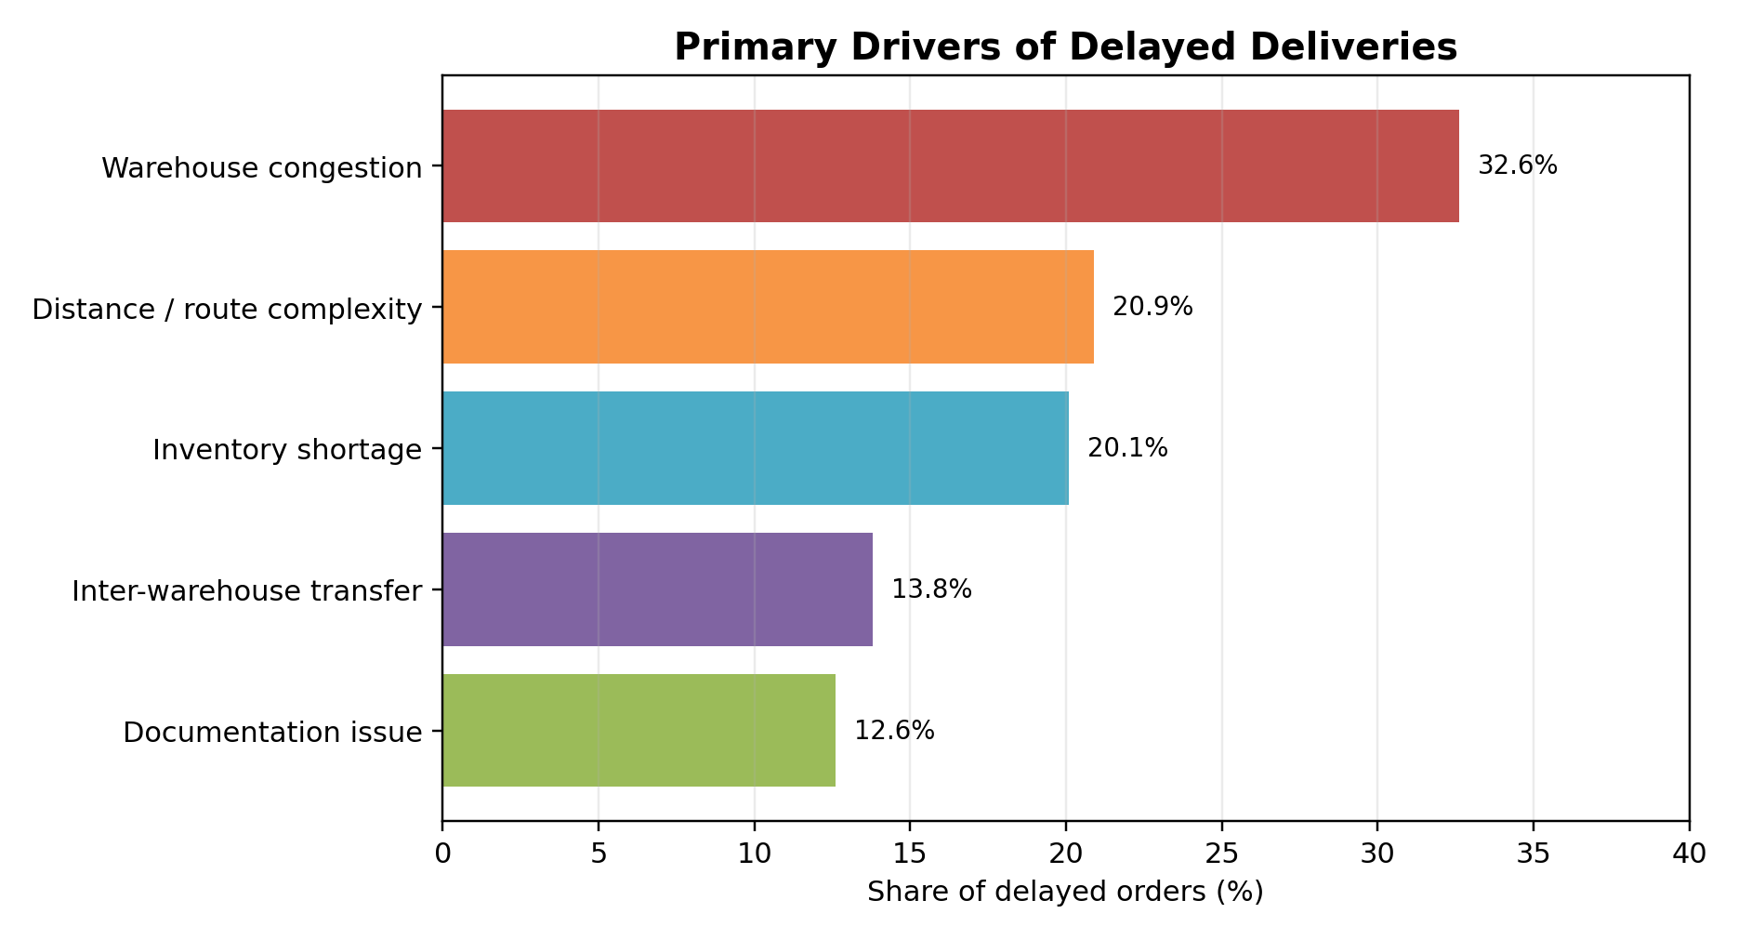
Figure 3. Primary drivers of delayed deliveries.

5.2 Predictive model comparison
Model | ROC-AUC | Accuracy | Precision | Recall | F1-Score
XGBoost | 0.936 | 0.889 | 0.757 | 0.678 | 0.715
Logistic Regression | 0.932 | 0.843 | 0.579 | 0.864 | 0.693
Random Forest | 0.914 | 0.850 | 0.605 | 0.776 | 0.680

Table 6. Model comparison on the simulated test set.
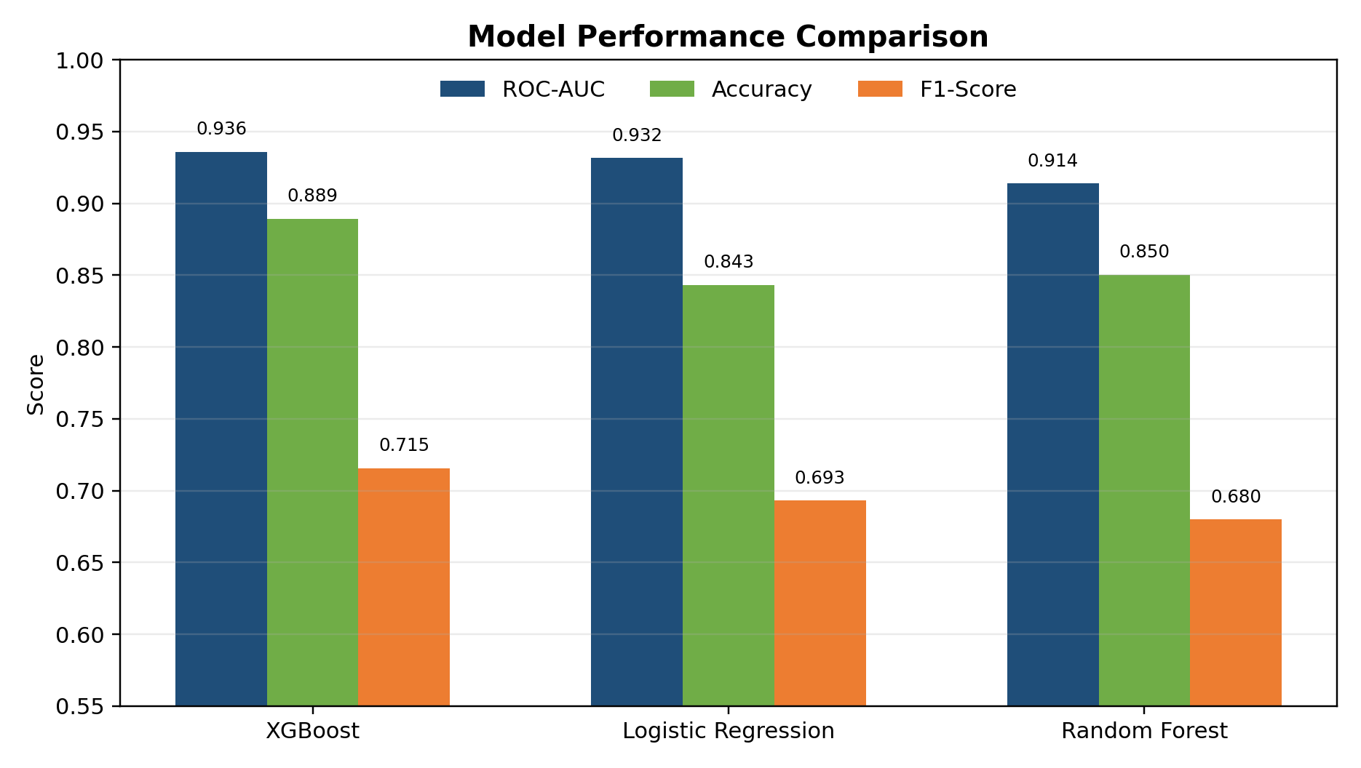
Figure 4. Comparative performance of Logistic Regression, Random Forest, and XGBoost.

5.3 Decision-making using data mining techniques
The case uses data mining in a business sense rather than a purely academic sense. Classification identifies which orders are likely to breach SLA. Segmentation can cluster similar high-risk patterns for managerial review. Association between features and outcomes helps design interventions. The purpose is not only to explain the past but to structure forward decisions. A project controller seeing a 0.82 predicted delay risk with a dominant ‘inter-warehouse transfer’ driver should act differently from a controller seeing a 0.82 risk caused mainly by queue congestion. This is the managerial value of combining prediction with interpretable operational features. This logic is aligned with CRISP-DM and business-oriented data mining, where classification, segmentation, and pattern discovery matter only when they inform decision design (Shearer, 2000; Schröer et al., 2021).

6. Digital Transformation Analysis
The digital transformation dimension of the case extends beyond the machine-learning model. Before transformation, delivery management was reactive, human-dependent, and fragmented across project engineers, warehouse staff, and dispatchers. After transformation, the workflow becomes event-driven: the ERP publishes a delivery event, the model scores delay risk, business rules classify the case, and RPA bots trigger status updates, site notifications, and SLA exception logging. This before-versus-after redesign is characteristic of digital transformation programs that combine analytics, process integration, and cross-functional visibility (Lam et al., 2024; Davenport & Brooks, 2004).
This redesign changes business processes in three ways. First, it compresses the time between ‘order created’ and ‘risk understood’. Second, it standardizes decisions that were previously dependent on who happened to follow up first. Third, it creates data feedback loops, because every prediction, intervention, and actual outcome can be written back into the ERP and later used for model monitoring. Lam et al. (2024) show that logistics digital transformation creates value when repetitive operational tasks are redesigned rather than merely digitized, a conclusion that strongly fits this case.
Automation of manual and repetitive tasks is especially valuable in telecom EPC operations because supervisors often spend time on low-value status chasing. In the proposed future state, RPA is not replacing the warehouse or project team; it is removing repetitive coordination friction. Three automation candidates are recommended: automatic ERP status updates when milestones change, automatic customer or site notifications when predicted risk crosses a threshold, and automatic SLA exception logging once a breach is predicted or confirmed. These three bots map directly to the user’s case requirements and provide a realistic bridge between prediction and action. In this sense, automation supports orchestration rather than labour substitution, which is consistent with current digital-transformation thinking in logistics operations (Lam et al., 2024).
The cultural impact is equally important. A predictive model changes decision-making norms. Managers move from arguing over anecdotes to discussing risk distributions, thresholds, and intervention economics. Customer experience also improves because communication becomes proactive. Instead of informing the site after a promised time has already passed, the organization can communicate a revised ETA earlier and preserve trust. The shift is therefore not only digital but managerial: it moves the company from reactive firefighting to controlled execution.

6.1 Before vs. after transformation
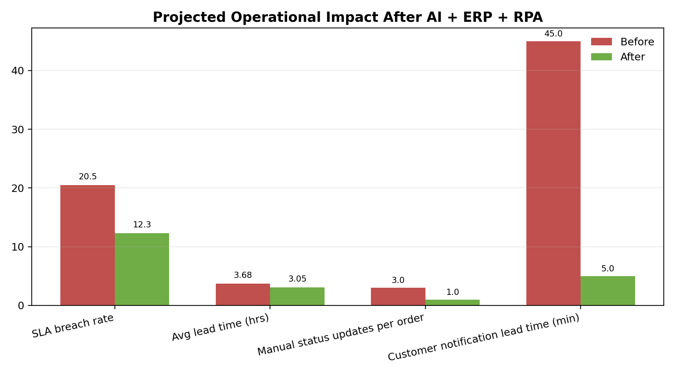
Figure 5. Projected before-vs.-after KPI movement after AI, ERP integration, and RPA enablement.

6.2 Conceptual dashboard

Figure 6. Example executive dashboard for delivery-risk monitoring.

7. ERP Integration and Process Design
ERP plays a central role in the proposed solution because it is the operational source of truth. In this case, the architecture is a hybrid environment: a telecom custom ERP governs project, order, and operational identifiers, while Odoo-based inventory and warehouse modules support stock status, lead-time configuration, replenishment logic, routes, and inter-warehouse transfers. Odoo documentation makes clear that lead times, replenishment methods, and route rules are configurable and directly shape expected delivery behavior (Odoo S.A., n.d.-b, n.d.-c, n.d.-d). That makes ERP integration not optional but foundational.
The main ERP modules involved are project operations, inventory and warehouse management, procurement, order management, finance/penalty tracking, and customer communication logs. Data flows from order confirmation into the AI scoring layer, then back into ERP objects as a risk score, risk driver, recommended action, and escalation status. Procurement and warehouse modules supply upstream variables such as backorder risk and inter-warehouse transfer dependency, while finance consumes downstream outputs such as penalty exposure and avoidable delay cost. This cross-functional flow is consistent with enterprise-systems logic, where transactional data gains value when it is shared across operational and financial processes (Davenport & Brooks, 2004).
The benefit of ERP plus AI integration is that it makes the model actionable. A standalone dashboard can tell executives that delay risk is rising, but only ERP integration can change the order record, reprioritize the workflow, notify the site, and store the event trail. Davenport and Brooks (2004) argue that enterprise systems create supply chain value when information flows across functions rather than staying within local silos. The current case supports that argument: the model becomes valuable only after its output touches warehouse, project, and customer-facing processes.
At the same time, ERP integration introduces challenges. Custom telecom ERPs often contain inconsistent data definitions, partially manual updates, and customized objects that are not cleanly documented. Moumane et al. (2024) identify high cost, system complexity, and staff training as persistent ERP implementation obstacles, and those issues remain relevant for AI integration as well. Therefore, data standardization, model governance, and change management should be treated as part of the implementation scope, not as post-project clean-up.

7.1 Process workflow and BPM
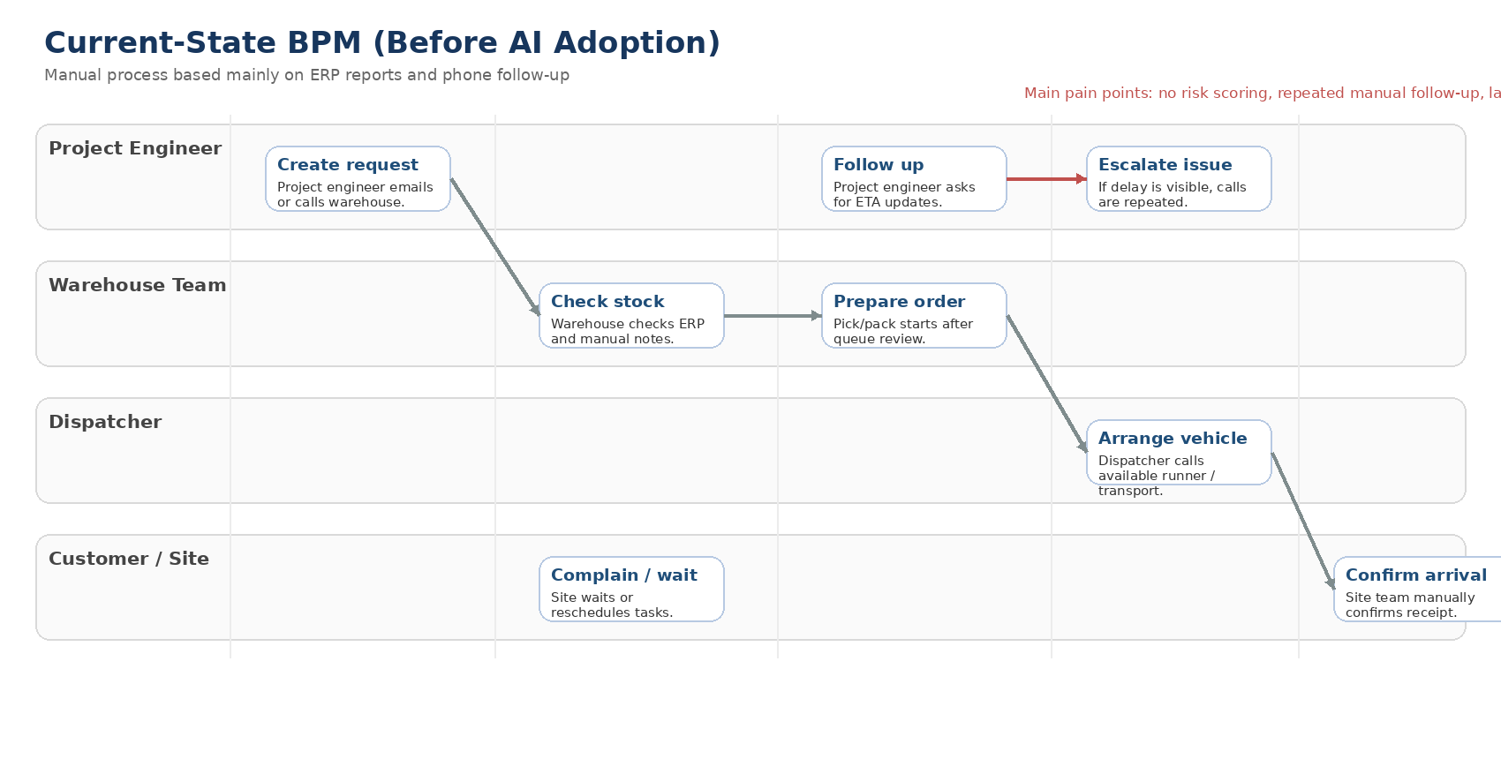
Figure 7. Current-state BPM before AI adoption.
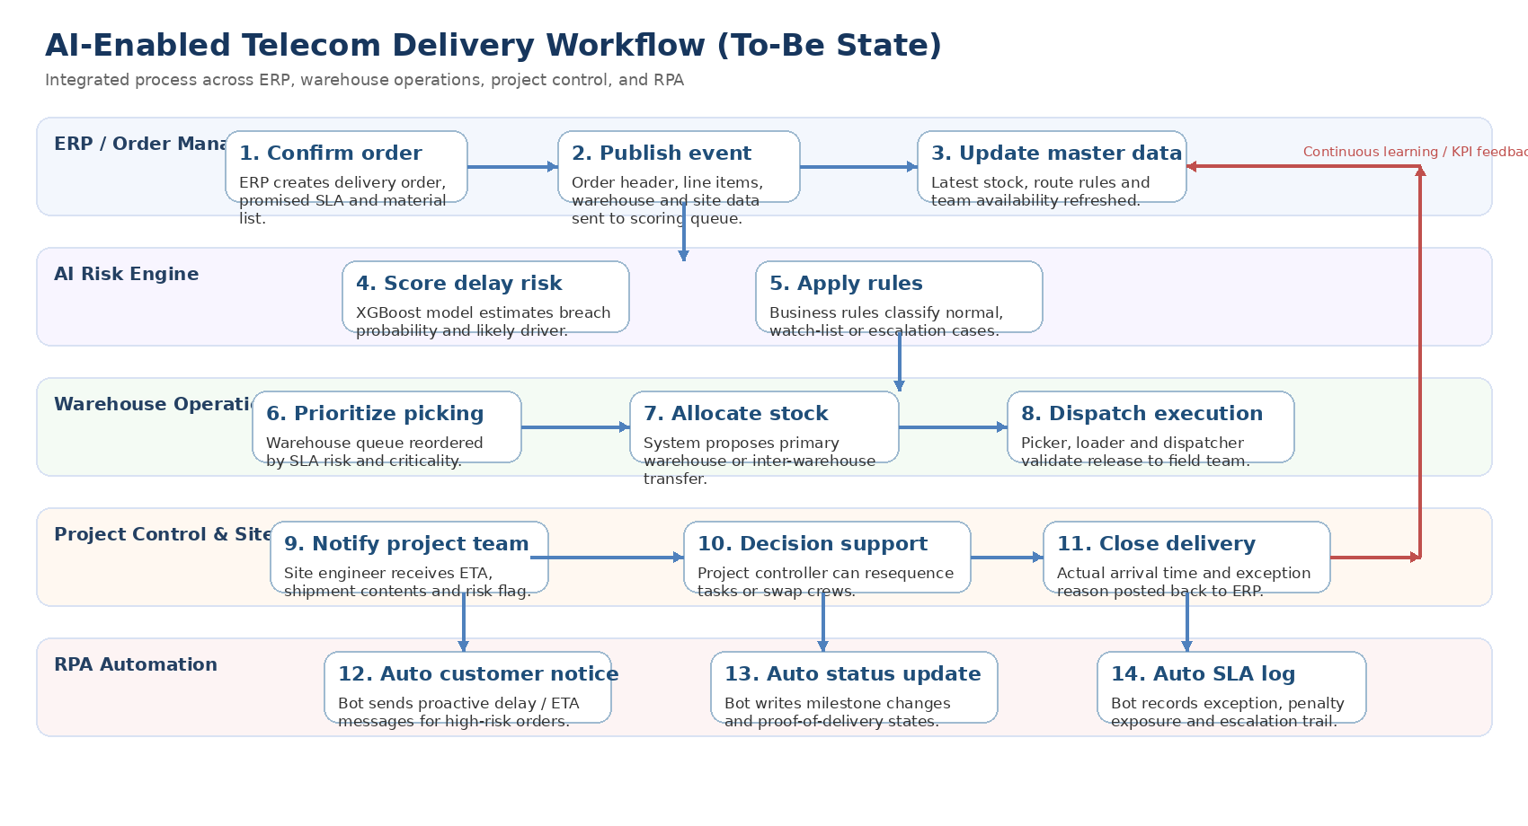
Figure 8. Future-state AI-enabled workflow linking ERP, AI, warehouse operations, project control, and RPA.

7.2 ERP data flow summary
Source step | Data passed | Business use
Order confirmation in telecom ERP | Order ID, site, SLA, material lines | AI scoring request
Odoo warehouse/inventory layer | Stock availability, route rules, inter-WH transfer, pick queue | Context enrichment for model
AI risk engine | Predicted breach probability + top drivers | Risk score returned to ERP and dashboard
RPA layer | Notification and exception rules | Customer notice, status update, SLA log
Finance / management reporting | Breach avoidance and penalty exposure | Benefit tracking and governance

Table 7. Simplified ERP–AI–RPA data flow.

8. SDLC Methodology and RPA Role
The recommended development methodology is Hybrid Agile SDLC. This choice is appropriate because the case combines two realities: the exploratory nature of machine learning and the governance discipline required for ERP-facing operational systems. A purely waterfall approach would delay user learning, while a purely agile approach may underweight controls, data governance, and release stability. Hybrid Agile creates short model and integration sprints within a structured delivery framework. The structure also mirrors the evolution of CRISP-DM toward more iterative and governance-aware analytics delivery in organizations (Shearer, 2000; Schröer et al., 2021).
The SDLC can be organized into five stages. Stage 1 is business understanding and success definition, including SLA, penalty, and productivity targets. Stage 2 is data engineering, where ERP fields, warehouse events, and exception logs are standardized. Stage 3 is modeling, validation, and explainability review. Stage 4 is pilot deployment in one warehouse or one project cluster. Stage 5 is scaled rollout with monitoring, retraining, and benefits tracking. This sequence also aligns with CRISP-DM, which remains a practical and widely used analytics process model for business-oriented data mining work (Schröer et al., 2021; Shearer, 2000).
RPA fits naturally inside this SDLC as the automation layer around the model. During the pilot, bots should remain narrowly scoped and highly visible. One bot updates ERP milestone fields; another pushes notifications to customers or site engineers; a third writes exception entries to the SLA register. This staged approach reduces adoption risk because users can see the logic, verify the outputs, and escalate exceptions before large-scale automation is expanded. The approach is consistent with digital-transformation practice that uses targeted automation to strengthen process responsiveness and control (Lam et al., 2024).
From a governance perspective, model monitoring should be embedded from the beginning. That includes drift checks, false positive review, user override logging, and periodic retraining. In a business environment, a model that performs well in the first quarter may degrade when route patterns, project mix, or warehouse policies change. Hybrid Agile is useful precisely because it recognizes that deployment is not the end of the project; it is the beginning of operational learning. This need for continuous monitoring aligns with both iterative analytics practice and risk-based control thinking (Schröer et al., 2021; ISO, n.d.).
Stage | Hybrid Agile focus | Expected output
Stage 1 | Business understanding | Define KPIs, breach economics, governance, and pilot scope
Stage 2 | Data engineering | Map ERP fields, clean master data, build scoring dataset
Stage 3 | Modeling and validation | Train, compare, and explain models; define thresholds
Stage 4 | Pilot deployment | Roll out to one warehouse or region with human oversight
Stage 5 | Scale and improve | Expand automation, monitor drift, retrain, and audit controls

Table 8. Recommended Hybrid Agile SDLC roadmap.

9. Business Impact and Value Creation
The projected business impact is material. Baseline performance shows 2,995 annual SLA breaches out of 14,600 orders. Under a conservative target scenario, AI-driven prioritization, ERP-triggered intervention, and RPA-based communication reduce the breach rate from 20.5% to 12.3%, equivalent to 1,199 avoided breaches per year. This is a meaningful improvement for a mid-sized telecom EPC logistics function.
A business case was built using three value levers: fewer penalties and emergency re-deliveries, higher technician productivity, and lower coordination overhead. Using moderate assumptions, the annual gross benefit is estimated at EGP 3.60 million. The main components are EGP 1.86 million from avoided SLA penalties and emergency logistics, EGP 0.94 million from lower technician waiting and better task sequencing, and EGP 0.80 million from reduced manual coordination and exception handling. Against an estimated first-year implementation cost of EGP 1.40 million, the project yields an indicative first-year ROI of 157% and a payback period of less than six months.
The strategic value is broader than the financial estimate. Better prediction improves customer credibility, supports disciplined scale-up, and gives management a reusable analytics capability for adjacent use cases such as stockout prediction, crew scheduling, or supplier delay risk. This supports long-term sustainability because the organization learns how to institutionalize decision intelligence rather than solving one narrow symptom.

9.1 KPI and financial summary
KPI | Formula / definition | Before | After | Why it matters
SLA breach rate | Delayed orders / total orders | 20.5% | 12.3% | Primary reliability metric
Average lead time | Mean actual delivery hours | 3.68 h | 3.05 h | Operational speed
Manual status touches per order | Average number of calls/messages/manual updates | 3.0 | 1.0 | Coordination effort
Customer notification lead time | Minutes between risk detection and customer/site notification | 45 min | 5 min | Service responsiveness
Avoided annual breaches | Baseline breaches – projected breaches | 0 | 1,199 | Direct contribution to savings

Table 9. KPI definitions and projected operational outcomes.
Value lever | Basis of estimate | EGP
Avoided penalties and emergency logistics | 1,199 avoided breaches x blended savings per event | 1,860,000
Technician productivity gain | Lower waiting time and better task resequencing across 50 teams | 940,000
Reduced manual coordination overhead | Fewer phone follow-ups, manual updates, and exception handling | 800,000
Total projected annual gross benefit | Sum of above | 3,600,000
Estimated year-1 implementation cost | Data engineering, model build, ERP integration, training, support | 1,400,000
Indicative year-1 ROI | (3.60m - 1.40m) / 1.40m | 157%

Table 10. Indicative value-creation model for the case.

10. Risks, Ethical Issues, Limitations and ISO/IEC 27001 Alignment
No MBA case on AI should ignore risk. In this project, the first concern is data privacy and security. The model may process employee names, contact details, customer contacts, site addresses, and possibly vendor data. Under EU rules, personal data includes identifiers such as names, email addresses, IP addresses, and any information that can relate to an identifiable person (European Commission, n.d.-a). The GDPR also sets seven core principles, including lawfulness, fairness and transparency, purpose limitation, data minimisation, storage limitation, accuracy, integrity and confidentiality, and accountability (European Commission, n.d.-b). Even when the contractor is Egypt-based, these principles remain a strong benchmark whenever EU-linked data subjects, cloud processors, or multinational customers are involved.
The second concern is model bias and decision fairness. If historical prioritization practices were already uneven, the model may learn those patterns. For example, some regions or project types may historically receive faster attention because they are managed by stronger supervisors, not because they are objectively more urgent. This is why model outputs should support managerial judgement, not silently replace it. Human override with audit logging is therefore a control, not a weakness.
The third concern is adoption risk. Users may reject a system that looks statistically impressive but operationally disruptive. Logistic teams often distrust models when they cannot see why a specific order was flagged. For this reason, the project should expose driver-level explanations, threshold logic, and exception histories inside the ERP interface. If the model is explainable and the intervention path is simple, adoption improves.
ISO/IEC 27001 provides a useful control frame because it treats information security as a risk-managed system rather than as a one-time technical fix. ISO states that ISO/IEC 27001 is the world’s best-known information security management systems standard and that it supports risk management, cyber-resilience, and operational excellence (ISO, n.d.). For this case, the most relevant clauses and control themes are risk assessment and treatment, operational control, access management, logging and monitoring, backup, supplier security, and incident response. In operational terms, that means controlling who can view risk scores, logging every automated update, protecting training data extracts, securing interfaces with ERP vendors or cloud providers, and defining an incident path when the model or bot behaves unexpectedly.
The study also has limitations. The dataset is simulated, not an audited production export. No live vehicle telemetry, dynamic traffic, or IoT signals were available. The financial case is directional rather than contractual. Finally, the model predicts breach probability, not the exact duration of late arrival. Future work can extend the solution into delay-duration forecasting, route optimization, and reinforcement learning-based dispatch policies.

10.1 Risk and control mapping
Framework element | Relevance | Case application
GDPR principles | Purpose limitation, data minimisation, accuracy, integrity/confidentiality, accountability | Limit personal fields in training data; define retention, access, and audit rules
ISO/IEC 27001 Clause 6 | Risk assessment and treatment | Assess model misuse, interface failure, data leakage, and inaccurate automation risk before go-live
ISO/IEC 27001 Clause 8 | Operational planning and control | Define controlled deployment, bot runbooks, approval thresholds, and rollback procedures
ISO/IEC 27001 Clause 9 | Performance evaluation | Monitor drift, false positives, user overrides, and control effectiveness
ISO/IEC 27001 Clause 10 | Continual improvement | Use incidents, audit results, and KPI gaps to refine controls and retraining cycles
Supporting control themes | Access management, logging, backup, supplier security, incident response | Restrict model access, log automated actions, secure backups, review vendor/API exposure

Table 11. GDPR and ISO/IEC 27001 alignment for the proposed solution.

11. Recommendations and Future Scope
Three strategic recommendations emerge from the analysis. First, implement the solution as an operational decision-support system, not as a stand-alone analytics dashboard. The model’s output should be embedded directly inside the order workflow so that risk is visible at the exact point where the warehouse, project control, and dispatcher must act. This recommendation is also consistent with enterprise-systems and digital-transformation literature, which shows that analytics creates more value when it is embedded in process execution rather than separated from it (Davenport & Brooks, 2004; Lam et al., 2024).
Second, start with one high-volume warehouse and a limited rule set. A phased pilot reduces adoption friction, allows rapid data cleaning, and produces trustworthy baseline-versus-pilot evidence. The first release should focus on high-risk order scoring, ERP status write-back, proactive notification, and SLA logging. Only after user confidence is established should the organization add more sophisticated optimization logic.
Third, treat AI capability as a platform. Once data quality, governance, and integration are stabilized, the same architecture can support related telecom EPC use cases: supplier delay risk, replenishment forecasting, route-risk segmentation, site readiness prediction, and penalty forecasting. In this sense, delay prediction should be viewed as the first practical application in a broader digital transformation roadmap.
- Add delay-duration regression after the first successful classification rollout.
- Introduce route clustering and location enrichment to improve prescriptive actions.
- Extend the architecture to supplier delay prediction and replenishment forecasting.
- Develop management dashboards that combine order risk, warehouse load, and penalty exposure.
- Create quarterly model governance reviews covering performance drift, bias, and control compliance.

12. Conclusion
This case shows that predicting delivery delays is not merely a data science exercise; it is a business redesign problem. For Nile For Integrated Solutions (NIS), the strongest value comes from combining machine learning, ERP integration, and selective RPA inside a disciplined Hybrid Agile delivery model. Using a realistic telecom EPC dataset, the study demonstrated that delay risk can be predicted with strong performance and translated into specific managerial actions. The case also showed that the value of AI becomes sustainable only when privacy, security, workflow design, and change management are treated with the same seriousness as model accuracy. For MBA decision-makers, the main lesson is clear: AI creates competitive advantage when it improves the timing and quality of operational decisions, not when it simply adds another dashboard. This synthesis is consistent with evidence that AI value in logistics emerges from integration, governance, and process redesign rather than model performance alone (Akbari & Do, 2021; Lam et al., 2024; Moumane et al., 2024).

References
Akbari, M., & Do, T. N. A. (2021). A systematic review of machine learning in logistics and supply chain management: Current trends and future directions. Benchmarking: An International Journal, 28, 2977–3005.
Baryannis, G., Validi, S., Dani, S., & Antoniou, G. (2019). Supply chain risk management and artificial intelligence: State of the art and future research directions. International Journal of Production Research, 57(7), 2179–2202.
Davenport, T. H., & Brooks, J. D. (2004). Enterprise systems and the supply chain. Journal of Enterprise Information Management, 17(1), 8–19.
European Commission. (n.d.-a). Data protection explained. https://commission.europa.eu/law/law-topic/data-protection/data-protection-explained_en
European Commission. (n.d.-b). Principles of the GDPR. https://commission.europa.eu/law/law-topic/data-protection/rules-business-and-organisations/principles-gdpr_en
Gabellini, M., Civolani, L., Calabrese, F., & Bortolini, M. (2024). A deep learning approach to predict supply chain delivery delay risk based on macroeconomic indicators: A case study in the automotive sector. Applied Sciences, 14(11), 4688. https://doi.org/10.3390/app14114688
ISO. (n.d.). ISO/IEC 27001:2022 – Information security management systems. https://www.iso.org/standard/27001
Lam, H. Y., Tang, V., & Wong, L. (2024). Raising logistics performance to new levels through digital transformation. International Journal of Engineering Business Management, 16, 1–20. https://doi.org/10.1177/18479790241231730
Moumane, K., Rharoubi, I., Razouk, C., Ait Abderrahman, H., & El Asri, I. (2024). Transforming ERP systems for supply chain management: Designing a machine learning-based framework to overcome implementation challenges. In Proceeding of the 7th International Conference on Logistics Operations Management (pp. 77–88). Springer. https://doi.org/10.1007/978-3-031-68628-3_8
Müller, N., Burggräf, P., Steinberg, F., Sauer, C. R., & Schütz, M. (2025). An analytical review of predictive methods for delivery delays in supply chains. Supply Chain Analytics, 11, 100130. https://doi.org/10.1016/j.sca.2025.100130
National Telecom Regulatory Authority. (n.d.-a). Industry. https://www.tra.gov.eg/en/industry/
National Telecom Regulatory Authority. (n.d.-b). Telecom market. https://www.tra.gov.eg/en/industry/telecom-market/
National Telecom Regulatory Authority. (2025, February 27). National Telecommunications Regulatory Authority (NTRA) issues Q4 2024 mobile network quality report. https://www.tra.gov.eg/en/national-telecommunications-regulatory-authority-ntra-issues-q4-2024-mobile-network-quality-report/
Odoo S.A. (n.d.-a). Inventory. https://www.odoo.com/documentation/18.0/applications/inventory_and_mrp/inventory.html
Odoo S.A. (n.d.-b). Lead times. https://www.odoo.com/documentation/18.0/applications/inventory_and_mrp/inventory/warehouses_storage/replenishment/lead_times.html
Odoo S.A. (n.d.-c). Inter-warehouse replenishment. https://www.odoo.com/documentation/18.0/applications/inventory_and_mrp/inventory/warehouses_storage/replenishment/resupply_warehouses.html
Odoo S.A. (n.d.-d). Routes and push/pull rules. https://www.odoo.com/documentation/18.0/applications/inventory_and_mrp/inventory/shipping_receiving/daily_operations/use_routes.html
Schröer, C., Kruse, F., & Marx Gómez, J. (2021). A systematic literature review on applying CRISP-DM process model. Procedia Computer Science, 181, 526–534. https://doi.org/10.1016/j.procs.2021.01.199
Shearer, C. (2000). The CRISP-DM model: The new blueprint for data mining. Journal of Data Warehousing, 5(4), 13–22.
Steinberg, F., Burggräf, P., Wagner, J., Heinbach, B., Saßmannshausen, T., & Brintrup, A. (2023). A novel machine learning model for predicting late supplier deliveries of low-volume-high-variety products with application in a German machinery industry. Supply Chain Analytics, 1, 100003. https://doi.org/10.1016/j.sca.2023.100003
van Engelen, J. E., & Hoos, H. H. (2020). A survey on semi-supervised learning. Machine Learning, 109, 373–440. https://doi.org/10.1007/s10994-019-05855-6

